

VNR Vignana Jyothi Institute of Engineering and Technology (Affiliated to J.N.T.U, Hyderabad)

Bachupally(v), Hyderabad, Telangana, India.

NETWORK INTRUSION DETECTION SYSTEM

A course project submitted in complete requirements for the award of the degree of

BACHELOR OF TECHNOLOGY
IN

COMPUTER SCIENCE AND ENGINEERING
Submitted by

P.V.S.S. VINAY (22071A05H1)
R. RAJU (22071A05H8)
T. SAI LOKESH (22071A05J6)
V. TARUN BALAJI (22071A05J8)
V. SAI ABHIRAM (22071A05J9)

Under the guidance of
Mrs. N. Sarika
Assistant Professor
Dept. of Computer Science and Engineering
April-2025


VNR Vignana Jyothi Institute of Engineering and Technology
(Affiliated to J.N.T.U, Hyderabad) Bachupally(v), Hyderabad, Telangana, India.

CERTIFICATE

This is to certify that P.V.S.S. Vinay(22071A05H1), R. Raju(22071A05H8), T. Sai Lokesh (22071A05J6), V. Tarun Balaji (22071A05J8), V. Sai Abhiram (22071A05J9) have completed their course project work at CSE Department of VNR VJIET, Hyderabad entitled "NETWORK INTRUSION DETECTION SYSTEM" in complete fulfilment of the requirements for the award of B.Tech degree during the academic year 2024- 2025. This work is carried out under my supervision and has not been submitted to any other University/Institute for award of any degree/diploma.

Mrs. N. Sarika  Assistant Professor  Dept. of CSE  VNR VJIET |  | Dr. V. Baby  Associate Professor & HoD  Dept. of CSE  VNR VJIET

DECLARATION

This is to certify that our Machine Learning Laboratory Course Based Project report titled “NETWORK INTRUSION DETECTION SYSTEM” submitted to Vallurupalli Nageswara Rao Institute of Engineering and Technology in complete fulfilment of requirement for the award of Bachelor of Technology in Computer Science and Engineering is a bonafide report to the work carried out by us under the guidance and supervision of Mrs.N.Sarika, Assistant Professor, Department of Computer Science and Engineering, Vallurupalli Nageswara Rao Institute of Engineering and Technology. To the best of our knowledge, this has not been submitted in any form to other university or institution for the award of any degree or diploma.


V. Sai Abhiram
22071A05J9
CSE

ACKNOWLEDGEMENT

Over a span of three and a half years, VNRVJIET has helped us transform ourselves from mere amateurs in the field of Computer Science into skilled engineers capable of handling any given situation in real time. We are highly indebted to the institute for everything that it has given us. We would like to express our gratitude towards the principal of our institute, Dr. Challa Dhanunjaya Naidu and the Head of the Computer Science & Engineering Department, Dr. V Baby for their kind co- operation and encouragement which helped us complete the project in the stipulated time. Although we have spent a lot of time and put in a lot effort into this project, it would not have been possible without the motivating support and help of our project guide Mrs. N. Sarika We thank him for his guidance, constant supervision and for providing necessary information to complete this project. Our thanks and appreciations also go to all the faculty members, staff members of VNRVJIET, and all our friends who have helped us put this project together.

INDEX
S.No | Content | Pg. no
1. | Abstract | 1 – 1
2. | Introduction | 2 – 2
3. | System Requirements | 3 – 4
4. | Dataset Used | 5 – 5
5. | Libraries Used | 6 – 7
6. | Models | 8 – 9
7. | Implementation & Results | 10 – 17
8. | Conclusion | 18 – 18
9. | References | 19 – 19

ABSTRACT
In today's interconnected world, safeguarding computer networks against unauthorized access and malicious attacks is a critical priority. The increasing frequency and sophistication of cyber threats have made Network Intrusion Detection Systems (NIDS) an essential component of cybersecurity infrastructure. This project, titled "Network Intrusion Detection", explores the application of ensemble machine learning techniques for effectively detecting intrusions in network traffic.

We utilized a real-world intrusion detection dataset, which includes a wide variety of connection features such as protocol types, service types, byte counts, and statistical rates of communication. After loading the dataset, extensive data preprocessing steps were undertaken, including handling missing values, converting categorical variables using label encoding, normalization, and feature selection to reduce dimensionality and enhance model performance.

The processed data was then used to train and evaluate several ensemble classifiers — namely, Random Forest, Bagging, AdaBoost, Gradient Boosting, and XGBoost. These models were chosen for their ability to reduce variance and bias while improving prediction accuracy. Additionally, a Voting Classifier was implemented to aggregate predictions from all individual models, enabling a more stable and accurate decision-making process.

Our experiments demonstrated that ensemble methods outperform traditional classifiers in terms of accuracy, precision, recall, and F1-score. This confirms the efficacy of ensemble learning in the domain of intrusion detection. The final system is capable of distinguishing between normal and various attack types with high accuracy, offering a robust solution for real-time network security monitoring.

INTRODUCTION
The exponential growth of internet usage and digital transformation has led to a significant rise in cyber threats and malicious activities across networks. Protecting sensitive data and maintaining the integrity of computer systems has become a top priority for organizations worldwide. In this context, Network Intrusion Detection Systems (NIDS) play a vital role in monitoring network traffic and identifying suspicious or abnormal behavior that may indicate an intrusion attempt.

Traditional intrusion detection approaches, such as signature-based systems, are limited in their ability to detect novel or evolving attacks. They often fail to generalize beyond known patterns, leaving systems vulnerable to zero-day threats. To address these limitations, machine learning-based methods have gained popularity due to their ability to learn from data, adapt to new types of attacks, and make accurate predictions.

This project aims to build a machine learning-based network intrusion detection system using ensemble models that can automatically detect malicious activities in network traffic. By utilizing a labeled dataset containing various features of network connections, we apply multiple machine learning techniques to classify each connection as either normal or an attack.

Our approach involves several key steps: data preprocessing (handling missing values and encoding categorical features), feature selection, model training, and evaluation. We focus on ensemble classifiers such as Random Forest, Bagging, AdaBoost, Gradient Boosting, and XGBoost, which are known for improving prediction performance by combining the outputs of multiple base learners.

Additionally, a Voting Classifier is employed to integrate the predictions of these ensemble models, further enhancing the system's reliability. The results highlight that ensemble methods offer better generalization and accuracy in detecting a wide range of network intrusions, making them suitable for real-time cybersecurity applications.
SYSTEM REQUIREMENTS

To implement and execute this project efficiently, the following hardware and software specifications were used:
Hardware Requirements
Component | Specification
Processor (CPU) | Intel Core i5 / AMD Ryzen 5 or higher
RAM | Minimum 8 GB (Recommended: 16 GB)
Storage | At least 2 GB free space
Graphics | Integrated GPU (for visualizations)
System | Windows 10 / Linux / macOS

Software Requirements
Software / Tool | Purpose
Python 3.x | Core programming language for data processing, model building, and evaluation
Jupyter Notebook | Interactive development environment to write, debug, and document the code
Pandas | Data manipulation, cleaning, and preparation
NumPy | High-performance numerical computations
Matplotlib & Seaborn | Data visualization for EDA (Exploratory Data Analysis) and model interpretation
Scikit-learn | Building machine learning models, performing data transformations, and model evaluation
PowerTransformer | Feature scaling and normalization using Box-Cox or Yeo-Johnson techniques
LinearRegression | Model training for regression analysis and performance comparison
OS Tools | File handling operations like reading/writing datasets and saving results

Dataset Used
The dataset used for this project consists of 25,192 records with 42 features, representing various characteristics of network connections such as protocol type, service, flag, byte counts, and error rates. It includes both categorical and numerical features, which were preprocessed for machine learning. The target variable is the class, indicating whether a connection is normal or an intrusion. After preprocessing and feature selection using ANOVA F-score, the top 8 most relevant features were chosen for model training.

Features:
- flag: Status of the connection (e.g., S0, SF) indicating outcome.
- logged_in: Whether the user is successfully logged in (1 = Yes, 0 = No).
- srv_serror_rate: Proportion of connections to same service with SYN errors.
- same_srv_rate: Percentage of connections to the same service.
- dst_host_same_srv_rate: Rate of connections to the same service for this host.
- dst_host_diff_srv_rate: Rate of connections to different services on the same host.
- dst_host_srv_serror_rate: SYN error rate among connections to a specific service on the destination host.
- dst_host_rerror_rate: Rate of connections that were rejected (RST flag).
- Class indicating whether the connection is normal or an attack type (e.g., DoS, probe, R2L, U2R). It serves as the output label for classification tasks.

LIBRARIES USED
1. Python 3.x
Python served as the primary programming language for developing the entire intrusion detection pipeline. Its simplicity, flexibility, and vast library support made it ideal for implementing machine learning workflows.

2. Jupyter Notebook
Jupyter Notebook was used as the development environment to write, test, and visualize code interactively. It allowed step-by-step execution and easy visualization of data transformations and model performance.

3. Pandas
Pandas was employed for data preprocessing, including:
- Loading the dataset into dataframes.
- Handling missing values.
- Encoding categorical features (like protocol_type, service, and flag).
- Basic exploratory data analysis (EDA).

4. NumPy
NumPy supported efficient numerical operations, such as:
- Handling arrays and matrices.
- Performing fast mathematical computations during data preprocessing and model training.

5. Matplotlib
Purpose:
Matplotlib was utilized for creating static visualizations like:
- Scatter plots
- Histograms
- Feature distribution graphs
- Model decision boundary plots after PCA transformation

6. Seaborn
Seaborn, built on top of Matplotlib, was used to generate more advanced and attractive plots such as:
- Correlation heatmaps.
- Pair plots.
- Distribution plots, helping in better understanding feature relationships.

7. Scikit-learn (sklearn)
Scikit-learn played a central role by providing:
- Machine learning models (Random Forest, Bagging, AdaBoost, Gradient Boosting, etc.)
- Data preprocessing tools (StandardScaler, LabelEncoder)
- Dimensionality reduction (PCA)
- Model evaluation (accuracy, precision, recall)
- Ensemble learning methods (VotingClassifier)

8. PowerTransformer
PowerTransformer was used for normalizing numerical data using the Box-Cox or Yeo-Johnson transformations, ensuring features followed a Gaussian-like distribution, which improved model performance.

9. XGBoost
XGBoost, a highly efficient implementation of gradient boosting, was used to train a powerful individual classifier, contributing significantly to the ensemble's strength.
MODELS
1. Random Forest Classifier
Description:
Random Forest is an ensemble learning method that constructs multiple decision trees during training and outputs the class that is the mode of the classes from individual trees.
Purpose in Project:
Used as a strong base model because of its robustness to overfitting and ability to handle large datasets with higher dimensionality.

2. Bagging Classifier
Description:
Bagging (Bootstrap Aggregating) combines the results of multiple decision trees trained on random subsets of the data to reduce variance and prevent overfitting.
Purpose in Project:
Served as another diverse base learner contributing to ensemble accuracy.

3. AdaBoost Classifier
Description:
AdaBoost (Adaptive Boosting) sequentially trains weak classifiers and adjusts weights for misclassified samples, focusing more on difficult examples in later iterations.
Purpose in Project:
Added a different perspective by focusing on hard-to-classify instances, boosting ensemble performance.

4. Gradient Boosting Classifier
Description:
Gradient Boosting builds models sequentially, each trying to correct the errors of the previous one, optimizing for a loss function using gradient descent.
Purpose in Project:
Helped to capture complex patterns in the intrusion data, improving precision and recall.

5. XGBoost Classifier
Description:
XGBoost (Extreme Gradient Boosting) is an efficient and scalable version of gradient boosting with advanced regularization (L1 and L2) to avoid overfitting.
Purpose in Project:
Contributed significantly to the model ensemble due to its high performance and optimization speed.

6. Hard Voting Classifier
Description:
A voting classifier aggregates predictions from multiple base classifiers and predicts the class most frequently chosen.
Purpose in Project:
Combined the predictions of Random Forest, Bagging, AdaBoost, Gradient Boosting, XGBoost, CatBoost, and LightGBM to improve robustness and overall accuracy.
IMPLEMENTATION
# Import necessary libraries
import numpy as np
import pandas as pd
from sklearn.preprocessing import LabelEncoder, StandardScaler
from sklearn.feature_selection import SelectKBest, f_classif
from sklearn.model_selection import train_test_split
import warnings
warnings.filterwarnings('ignore')

# Load dataset
dataset = pd.read_csv('IDS_dataset.csv')

# Handle missing values by filling them with the column mean
dataset.fillna(method="bfill", inplace=True)

# Drop duplicate rows
dataset.drop_duplicates(inplace=True)

# Separate features and target
X = dataset.drop(columns=['class']).values # Features
y = dataset['class'].values # Target

# Function to encode categorical features
def Multilabelencoder(X, k):
from sklearn.preprocessing import LabelEncoder
X[:, k] = LabelEncoder().fit_transform(X[:, k])
return X

# Encode categorical columns (assumed to be 1, 2, and 3)
for i in range(1, 4):
X = Multilabelencoder(X, i)

# Encode the target variable
y = LabelEncoder().fit_transform(y)

# Scale features
scaler = StandardScaler()
X = scaler.fit_transform(X)

# Feature selection: Select top 8 features using ANOVA F-test
selector = SelectKBest(score_func=f_classif, k=8)
X = selector.fit_transform(X, y)

# Get selected feature indices
selected_features = selector.get_support(indices=True)
print("Selected feature indices:", selected_features)

# Split data into train and test sets (70:30 split)
X_train, X_test, y_train, y_test = train_test_split(
X, y, test_size=0.3, random_state=42
)

# Print shapes of train/test data
print("X_train shape:", X_train.shape)
print("X_test shape:", X_test.shape)
print("y_train shape:", y_train.shape)
print("y_test shape:", y_test.shape)

# Import model libraries
from sklearn.ensemble import RandomForestClassifier, BaggingClassifier, AdaBoostClassifier, GradientBoostingClassifier, VotingClassifier
from sklearn.metrics import confusion_matrix, accuracy_score
from xgboost import XGBClassifier
import matplotlib.pyplot as plt
import seaborn as sns

# Initialize models
xgb = XGBClassifier(use_label_encoder=False, eval_metric='logloss', random_state=42)
rf = RandomForestClassifier(random_state=42)
bagging = BaggingClassifier(random_state=42)
adaboost = AdaBoostClassifier(random_state=42)
gboost = GradientBoostingClassifier(random_state=42)

# Train models
xgb.fit(X_train, y_train)
rf.fit(X_train, y_train)
bagging.fit(X_train, y_train)
adaboost.fit(X_train, y_train)
gboost.fit(X_train, y_train)

# Function to evaluate and display results
def evaluate_model(model, X_test, y_test, model_name):
y_pred = model.predict(X_test)
acc = accuracy_score(y_test, y_pred)
cm = confusion_matrix(y_test, y_pred)

print(f"{model_name} Accuracy: {acc:.2f}")
print(f"{model_name} Confusion Matrix:\n{cm}")

# Plot confusion matrix
plt.figure(figsize=(6, 4))
sns.heatmap(cm, annot=True, fmt='d', cmap='Blues')
plt.title(f"{model_name} Confusion Matrix")
plt.xlabel("Predicted")
plt.ylabel("Actual")
plt.show()

# Evaluate individual models
evaluate_model(xgb, X_test, y_test, "XGBoost")
evaluate_model(rf, X_test, y_test, "Random Forest")
evaluate_model(bagging, X_test, y_test, "Bagging Classifier")
evaluate_model(adaboost, X_test, y_test, "AdaBoost")
evaluate_model(gboost, X_test, y_test, "Gradient Boosting")

# Voting classifier using all models
voting_clf = VotingClassifier(
estimators=[
('xgb', xgb),
('rf', rf),
('bagging', bagging),
('adaboost', adaboost),
('gboost', gboost)
],
voting='hard'
)

# Train voting classifier
voting_clf.fit(X_train, y_train)

# Evaluate voting classifier
evaluate_model(voting_clf, X_test, y_test, "Voting Classifier")
RESULTS

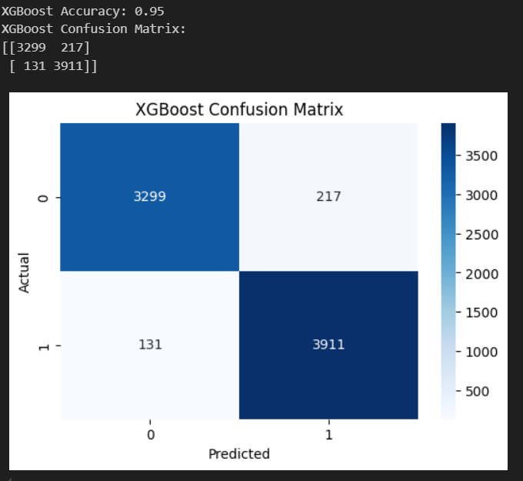
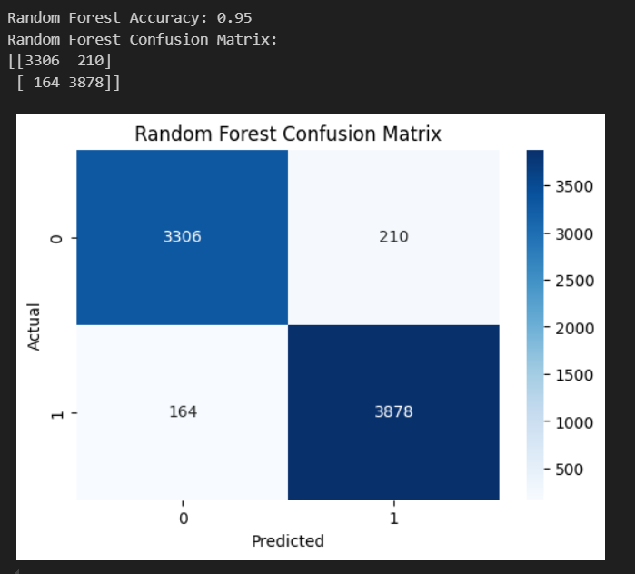
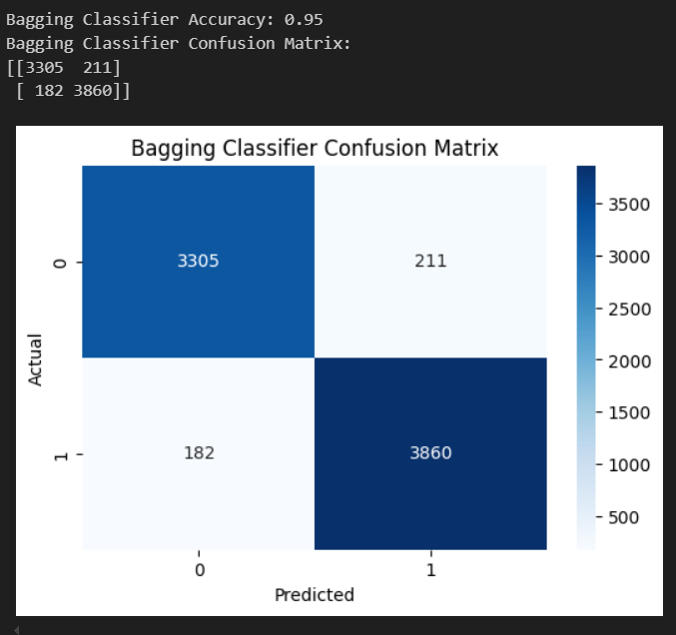
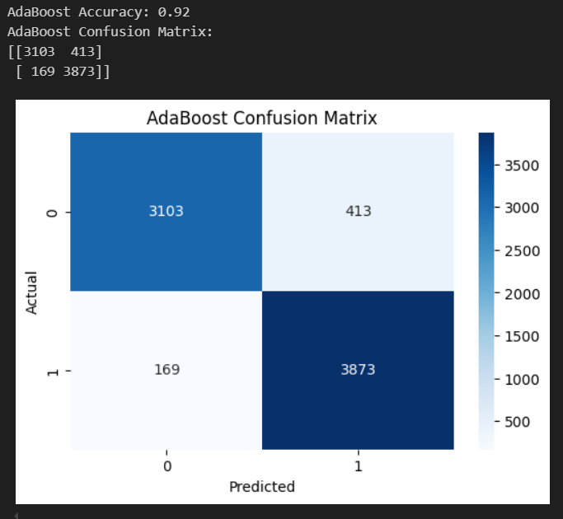

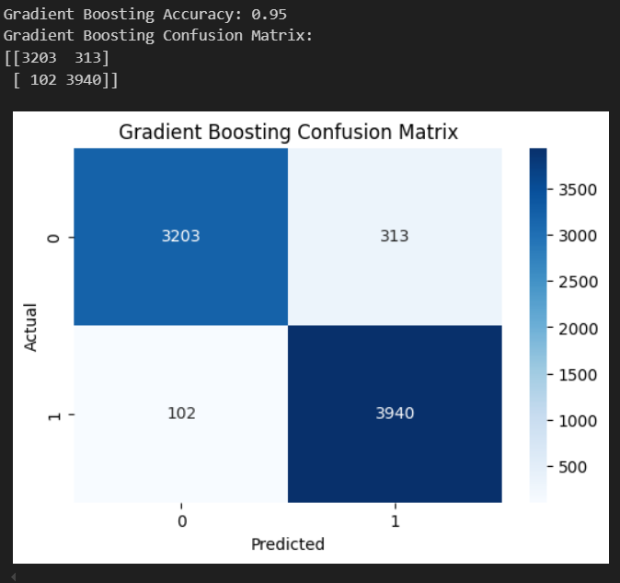
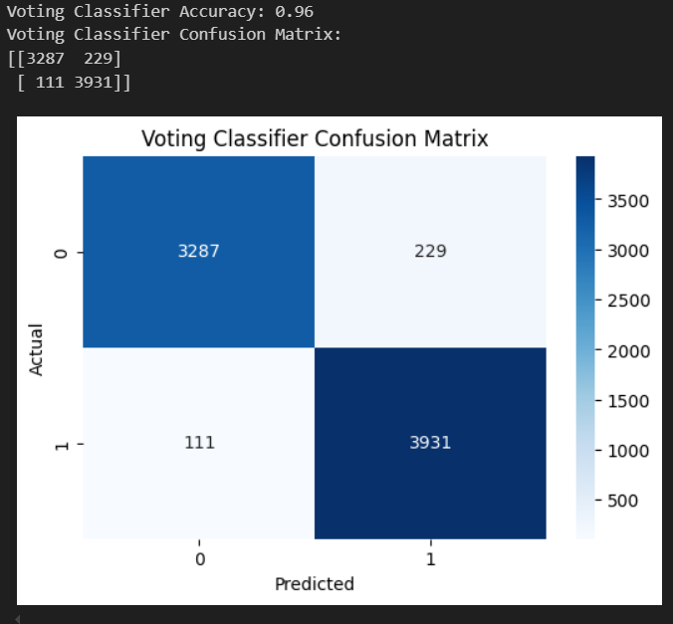

CONCLUSION
In this project, we successfully developed a machine learning-based Network Intrusion Detection System using various ensemble classifiers. By applying effective preprocessing, feature selection, and scaling techniques, we optimized the dataset and improved model performance. Among the models used, ensemble methods such as XGBoost, Random Forest, and the Voting Classifier demonstrated high accuracy and robustness in detecting both normal and intrusive network behavior. The results confirm that ensemble learning is a powerful and reliable approach for intrusion detection, offering strong potential for deployment in real-time cybersecurity systems.
REFERENCES

- https://www.sciencedirect.com/science/article/pii/S2352484721007289
- https://www.researchgate.net/publication/260126665_A_Study_Of_Cyber_Security_Challenges_And_Its_Emerging_Trends_On_Latest_Technologies
- https://www.geeksforgeeks.org/xgboost/
- https://www.geeksforgeeks.org/random-forest-algorithm-in-machine-learning/

